Oindrila Chatterjee
Darrell Collison
Waleed Jamil

IST 707, August 22nd 2025
US Opioid Overdose & Overdose Deaths
An Exploration of Indicators and emergent preventative actions by state
Insights from Machine Learning Models

IST 707,

Problem Statement
Since the early 2000’s, the opioid epidemic has remained a severe public health crisis in the United States. CDC (and NCHS) ^{1,2} reported that the age-adjusted rate of drug overdose deaths increased from 8.9 deaths per 100,000 standard population in 2003 to 32.6 in 2022^{6,7}. The crisis was exacerbated by the COVID-19 pandemic, which disrupted treatment and recovery services, as well as negatively impacted emotional wellbeing. Efforts to combat the crisis have been in focus recently and include increased funding for addiction treatment, harm reduction strategies and expanding access to naloxone - a life-saving medication that reverses overdoses. Challenges, however, still exist for Federal and Local governments.

While prescription opioid abuse has decreased slightly due to tighter prescribing regulations strategically managed by CDC¹ and NIDA³ and enforced by DEA⁴, deaths due to abuse of illegally made synthetic opioids, cocaine and psychostimulants – many times involving multiple drugs - continue to increase per NCHS^{6.7}. Moreover, there are geographical nuances in the apparent countrywide decline in opioid overdose deaths. In a CDC report, 6 states actually worsened in opioid death rates and 25 states remained at steady high rates^{6,7}. Challenges such as stigma around seeking drug use treatment services, insufficient resources, and the continued spread of fentanyl, psychostimulants and heroine remain significant hurdles for federal and local authorities in controlling overdoses in almost all states.

The ultimate reduction of drug overdose deaths will include steps to prevent opioid misuse as targeted by CDC, NIDA and DEA and expanding access to evidence-based treatment and recovery services. These treatment and recovery services include counselling, behavior therapy, medication-assisted treatment (buprenorphine, methadone and naltrexone) and most importantly, targeted naloxone distribution. Targeted naloxone distribution programs to train and equip individuals most likely to witness an overdose (people who use drugs and first responders) with naloxone kits, is key to reversing opioid overdose and avoiding deaths. To this end, Substance Abuse and Mental Health Services Administration (SAMHSA) and the Overdose Response Strategy (ORS) in CDC need crucial information to continuously manage and align naloxone supply and distribution in states with the highest estimated demand.

Given this environment as well as the professional interest of our team members, the focus of this class project is to investigate, analyze and generate predictions of various parameters impacting future opioid death rates by state in the US. This prediction will then to be compared to overlapping naloxone and buprenorophine dispensing rates to possibly identify gaps and inform the supply of these critical lifesaving therapies by involved Federal and Local Health agencies.
Stakeholders
The Substance Abuse and Mental Health Services Administration (SAMHSA) aims to improve behavioral health nationwide and support individuals with substance use disorders.
The Overdose Response Strategy (ORS) connects public health and safety agencies through collaboration between the CDC and the High-Intensity Drug Trafficking Areas (HIDTA) program orsprogram.org.
Many state and local health departments and community-based organizations who work to reduce drug overdose deaths.
Goal
This project aims to aggregate and analyze overdose death rate data by state from 2020-2023 from NCHS⁸ along with demographic ¹¹ and overdose data from CDC’s publicly available State Unintentional Drug Overdose Reporting System (SUDORS), as well as availability of naloxone and buprenorphine⁹ from CDC to project the number of opioid overdose deaths, the consequent total Naloxone demand and concurrently, the coverage by Targeted Naloxone (and buprenorphine) Program in the period 2026-2027. Adjustments to the Naloxone distribution program will then be derived from the outcome of these projections to support ORS and the health agencies associated with ORS.
Hypothesis
The historic 2020-2023 Opioid Overdose Deaths by state and Targeted Naloxone Dispensing Rates will be analyzed with clustering methods and then both Opioid Overdose Deaths and Targeted Naloxone Dispensing Rates will be projected for 2027 based on historic trends. The hypothesis to be tested is that states with historically decreasing deaths have concurrent high naloxone dispensing rates. The states with increasing death rates will then be tested for projected increasing naloxone dispensing to identify misalignments for recommendations of adjustments to ORS. The future national average dispensing rate will also be calculated such that the National supply can also be planned.

Datasets
All of our datasets are sourced from publicly available online government sources. These include The National Center for Health Statistics, CDC, and US Census websites. In addition to this we have explored several studies and datasets from data.gov as listed in the references. Given this we have a high degree of confidence in the data’s provenance.
- The SUDORS dataset from 2020-2023 for 50 US states has 144 rows and 274 columns with no missing values. It includes critical statistics on all drug death rates in general as well as total opioid death rates with breakout of death rates by specific agents. The data also includes statistics on death from illegal and counterfeit drugs. Summary statistics were calculated on the numerical columns to understand the distribution of values in each column in general. Figure 1 shows a distribution of drug overdose deaths per 100k in each state from 2020-2023. The distribution of all-drug death rates indicated a right-skewed pattern, reflecting the fact that while most jurisdictions report moderate rates, a subset of states experience significantly higher burdens.
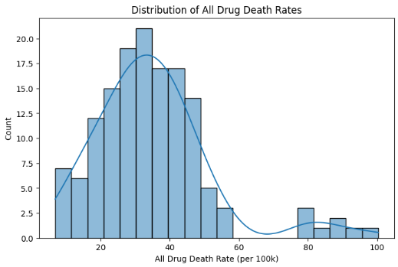
Figure 1: Distribution of annual drug death rates

Figure 2 shoes a correlation analysis among key substance categories highlighted strong associations between opioid-related deaths, stimulant-related deaths, and illicitly manufactured fentanyl (IMF) involvement, suggesting that polysubstance use plays an increasingly central role in driving overdose mortality.
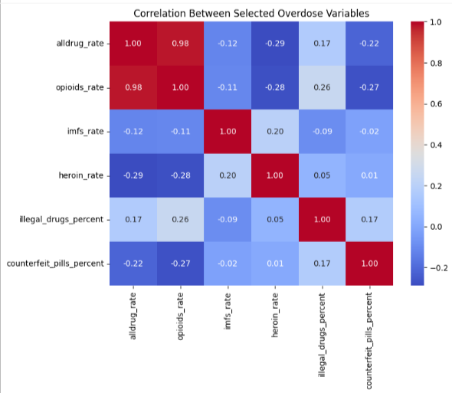
Figure 2: Correlation heatmap for selected variables

Preliminary modeling results: The dataset was initially split into train and test sets and both Logistic regression and random forest were tested for preliminary predictions of jurisdictions with high or low death rates from drug overdose. Both models generated results with high accuracy, precision, recall and F1 scores. Figure 3 shows that the most influential predictors of high-risk classification are the male overdose death rate, the overdose death rate among individuals aged 45–54, and the stimulant-related death rate. In this analysis, jurisdictions were classified as “high risk” when their overall drug overdose death rate exceeded the national median. The dominance of the male rate suggests that gender disparities play a central role in distinguishing high-risk areas, while the importance of the 45–54 age group highlights the vulnerability of middle-aged populations. The strong influence of stimulant-related deaths further underscores the growing role of stimulants, alongside opioids, in driving overdose risk.

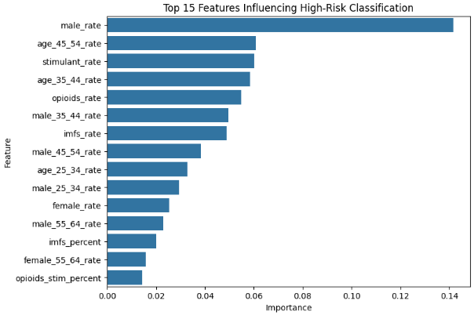
Figure 3: Top 15 features

- The naloxone dispensing rate data from 2020-2023 was also imported and analyzed. This dataset has 255 rows and 6 columns with no missing values. It is a simple dataset listing the year, the state name, the state abbreviation, numerical state code, the naloxone dispensing rate and categorization of the dispensing rate per 100 persons into 4 unique categories. There was no missing data in this set as well.

Figure 4: Evaluation of Naloxone Dispensing Rate
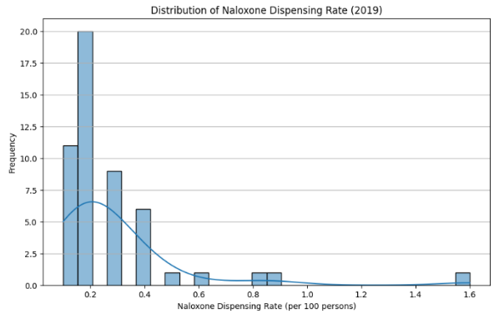 | 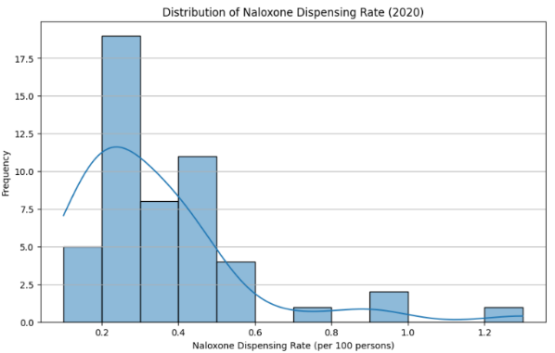
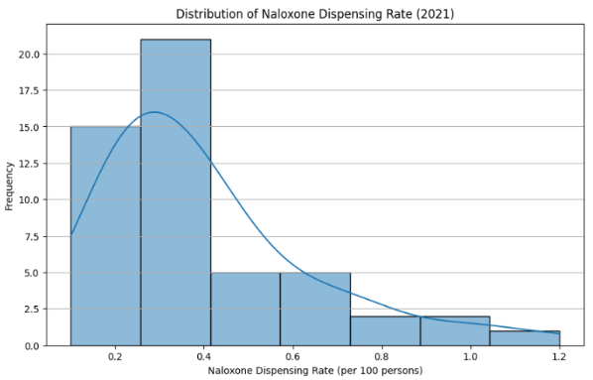 | 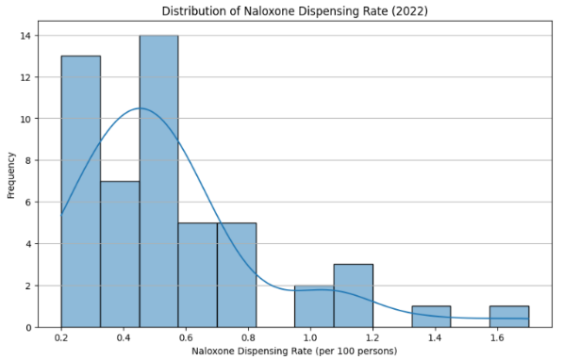
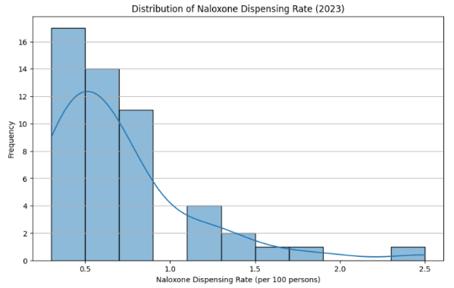
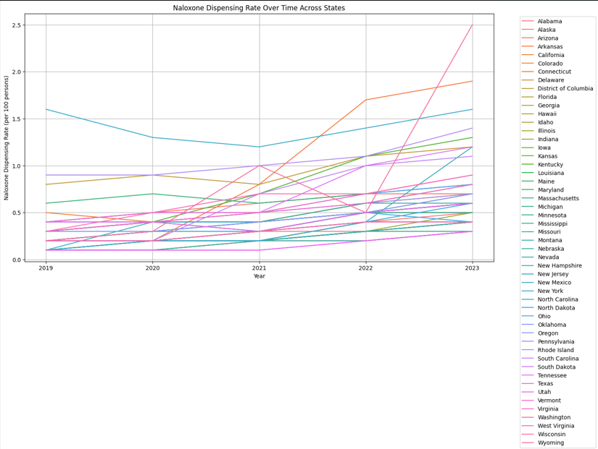
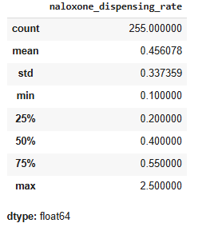

Preliminary modeling results: Linear and non-linear regressors were tested after using one hot encoder in the State Code (STATE_FIPS) column. Linear Regression explained about 77% of the variance in the data and scaling the data reduced the R² to 72%. XGBoost model with cross-validation and hyperparameter tuning also yielded a 0.7204 R² with no impact from scaling.

To improve predictions, the Random Forest Regressor was tested since it can capture non-linear relationships and interactions between features automatically. Feature engineering to capture the time series dependency was also found to be impactful on model performance. A Lagged Feature containing the dispensing rate from previous years iteratively for each state or historic rate was generated (previous_year_rate’) except for 2020 (data not available). Cross-validation and hyperparameter tuning along with the added feature achieved an R² of approximately 0.7905 and an RMSE of approximately 0.1677 on the test set. This indicates a reasonably good fit, explaining a significant portion of the variance in naloxone dispensing rates. The lagged dispensing rate feature, however, did not improve the XGBoost model results.

Figure 5: Projections of Naloxone Dispensing Rate by State
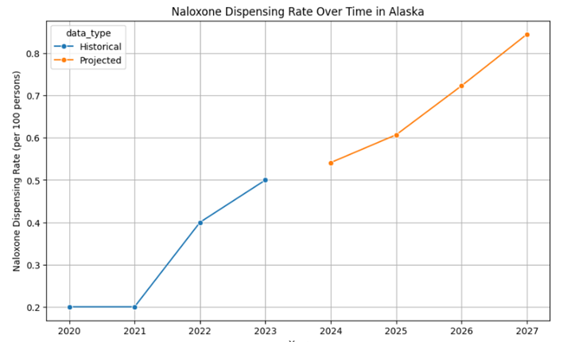
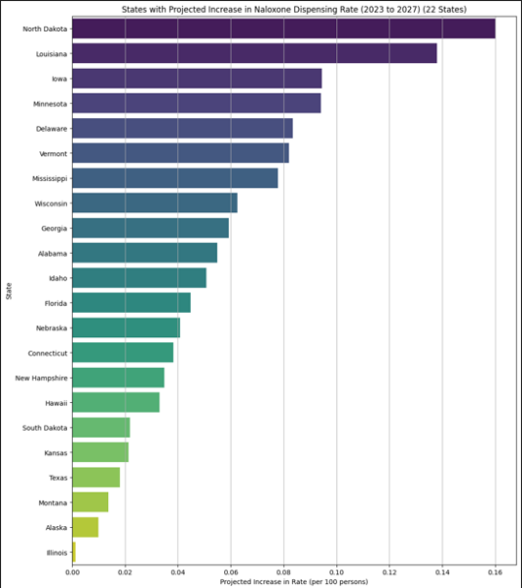 | 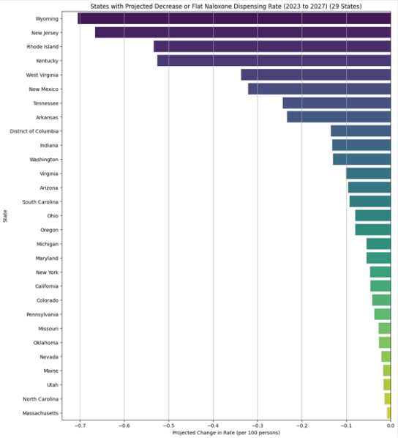

Conclusion of EDA and preliminary modeling: There is a strong indication of the suitability of both datasets tested for projection of opioid deaths and naloxone dispensing trends – particularly with Random Forest ensemble model - to pinpoint misalignments and recommend actionable adjustments to the Targeted Naloxone Program.
Methods
For this project we will be taking a two-pronged approach to explore and model the opioid overdose death rate outcome. Our first approach will focus on the availability and dispensing rate of naloxone and buprenorophine. The role of naloxone in lowering OD deaths is well established¹⁰. Given this, our goal is to align the projected OD deaths with naloxone dispensing rates in order to identify any potential gaps in the medication’s availability. Our secondary goal will be to create models that identify potential unexpected relationships between the factors, that could also lead to lowering the overdose death rate. In order to achieve these goals our methodology will be building 2 models simultaneously with the same dataset.
We will begin by combining the 3 datasets that we have listed and perform data preprocessing procedures to ensure standardization of all features. We will then evaluate different feature focus modeling techniques, feature selection and regressor models. We will then train the best of the 2 types of models and generate predictions.
Risks
This project has several risks primarily concerning the availability of data. Due to our interest in understanding the impact that naloxone and buprenorophine availability has had on overdose rates, we decided to include this as a key parameter. However, different states have different reporting criteria, and all states may have been impacted in their data collection strategies by the covid pandemic.

Our initial modelling and visualization efforts have also identified complexities and interdependencies within each dataset that could impact the model predictions, particularly involving naloxone dispensing. The accuracy of the random forest model on the combined data frame may be low. The addition of socio-economic parameters is expected to refine and improve the model but may yield contrary results.

References
¹ CDC focuses on preventing harms related to drug use and overdose through various strategies.
² The National Center for Health Statistics (NCHS) is the United States' principal health statistics agency. It is part of the Centers for Disease Control and Prevention (CDC). NCHS collects, analyzes, and disseminates timely, relevant, and accurate health data and statistics to guide health policies and programs.
³ The National Institute on Drug Abuse (NIDA) is a federal agency leading research on drug abuse for prevention, treatment, and public health.
⁴ The Drug Enforcement Administration (DEA) enforces drug laws and works to disrupt the illicit drug supply.
⁵ The National Academy of Medicine (NAM) has an initiative to develop solutions for reducing substance misuse.
⁶ https://www.cdc.gov/overdose-prevention/about/index.html#:~:text=However%2C%20drug%20overdose%20deaths%20declined,made%20fentanyl%20and%20fentanyl%20analogs.
⁷ https://www.cdc.gov/nchs/products/databriefs/db522.htm
⁸ https://www.cdc.gov/overdose-prevention/data-research/facts-stats/sudors-dashboard-fatal-overdose-data.html?utm_source=chatgpt.com
⁹ https://www.cdc.gov/overdose-prevention/data-research/facts-stats/us-dispensing-rate-maps.html
¹⁰ https://www.cdc.gov/overdose-prevention/reversing-overdose/about-naloxone.html ¹¹ https://www2.census.gov/programs-surveys/popest/datasets/2020-2024/state/totals/

